GEN AI
HANDS ON 1
Anish Kulkarni
PES2UG23CS074
20/1/26

Seed = 42
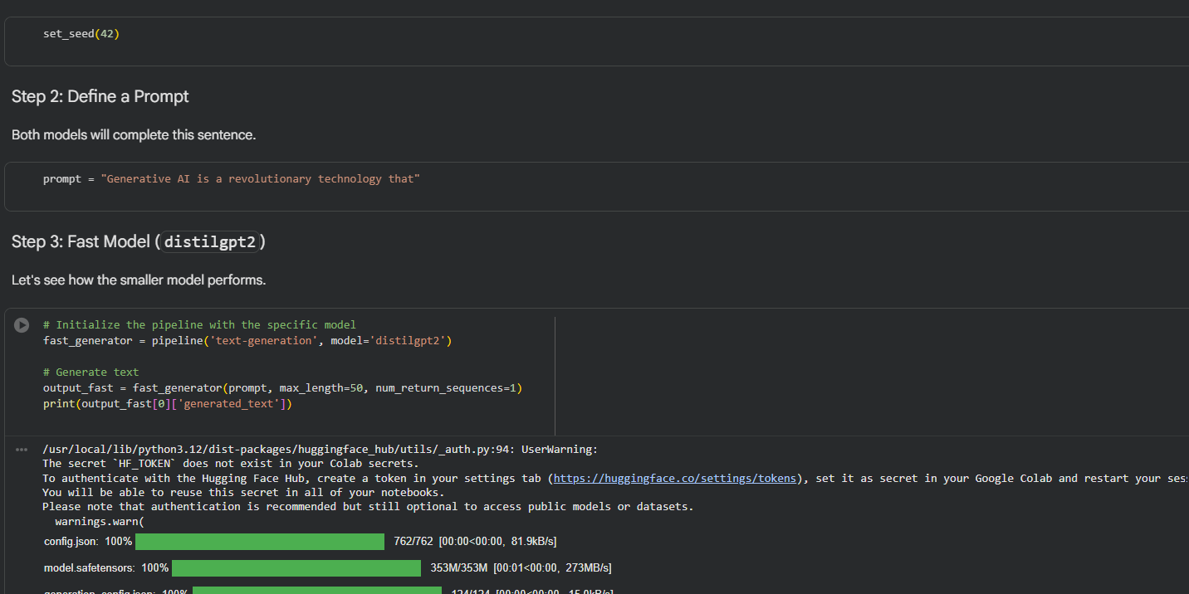
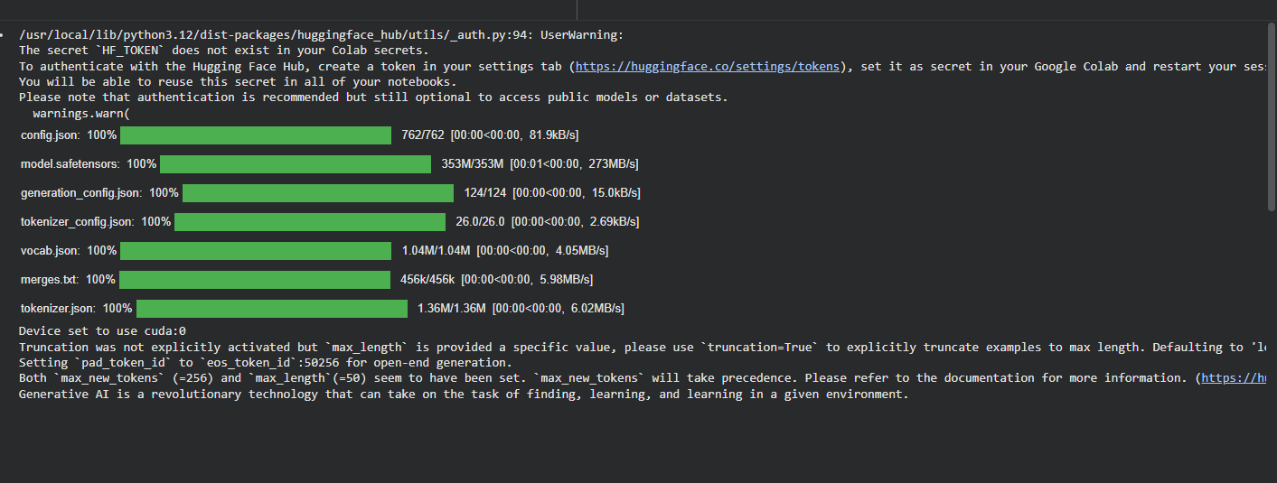
Seed = 67
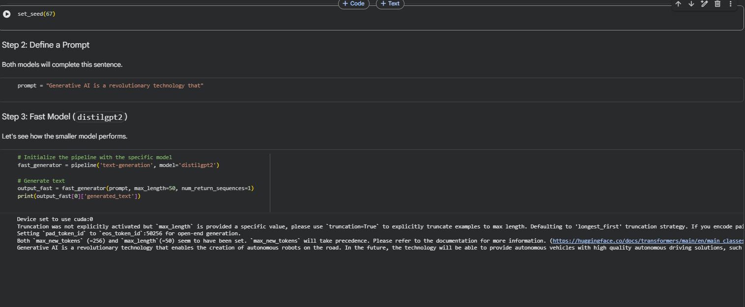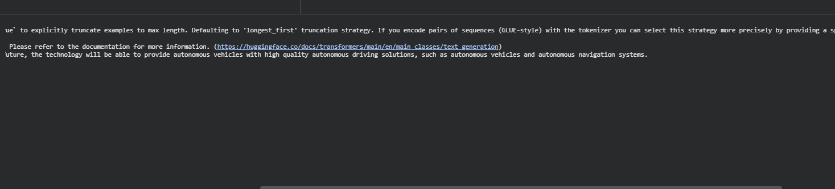
Observations:
Parts of Speech in GenAI
Parts of Speech (POS) are grammatical categories such as noun, verb, adjective, and adverb. In GenAI systems, POS helps models understand sentence structure, word relationships, and meaning, enabling accurate parsing, generation, and analysis of text.

Distilled Model
A distilled model is a smaller, faster neural network trained to mimic the behavior of a larger model. It retains most of the original model’s knowledge while reducing computation, memory usage, and deployment cost.

Standard Model
A standard model is the full-sized, original version of an AI system trained directly on large datasets. It offers the highest accuracy and capability but requires more computational power and memory than distilled models.

Tokenization
Tokenization is the process of splitting text into smaller units called tokens, such as words or subwords. It allows AI models to convert raw text into a structured form that can be processed numerically and efficiently.

POS Tagging (Part-of-Speech)
POS tagging assigns grammatical labels (noun, verb, adjective, etc.) to each word in a sentence. It helps NLP and GenAI systems understand sentence structure and word roles, improving parsing, generation, and semantic understanding.

Named Entity Recognition (NER)
Named Entity Recognition identifies and classifies important entities in text, such as people, organizations, locations, dates, and numbers. It enables GenAI systems to extract meaningful information from unstructured text for tasks like search and question answering.

BERT vs BART
BERT is designed for understanding text and is mainly used for tasks like classification, sentiment analysis, and question answering. BART combines understanding and generation, making it ideal for summarization, translation, and text generation tasks.

Summarization: Efficiency vs. Quality
Efficiency focuses on speed and low resource usage, making summarization suitable for real-time or large-scale applications. Quality emphasizes accuracy, coherence, and completeness, often requiring larger models and more computation, creating a trade-off between performance and cost.

